EXP NO 8

Create storyboards to represent the user flow for a mobile app (e.g., food delivery app) using Balsamiq

Mobile Food Delivery App

To visually represent the user flow of a mobile food delivery app using Balsamiq wireframes in storyboard format.

Step 1: Set Up Balsamiq
- Go to: https://balsamiq.com
- Download & Install Balsamiq Wireframes (Desktop or use Web app).
- Create a New Project from the dashboard.

Step 2: Define the User Flow (Storyboard Plan)

Wireframe 1: Home Screen

Purpose: Entry point where users search or choose cuisine.
Steps:
- Draw a mobile frame outline.
- At the top, write the heading: Home.
- Add a search bar with a magnifying glass icon.
- Below that, add 3-4 buttons labeled with food categories (e.g., Pizza, Sushi, Burgers).
- Use simple boxes and rounded corners for input fields.
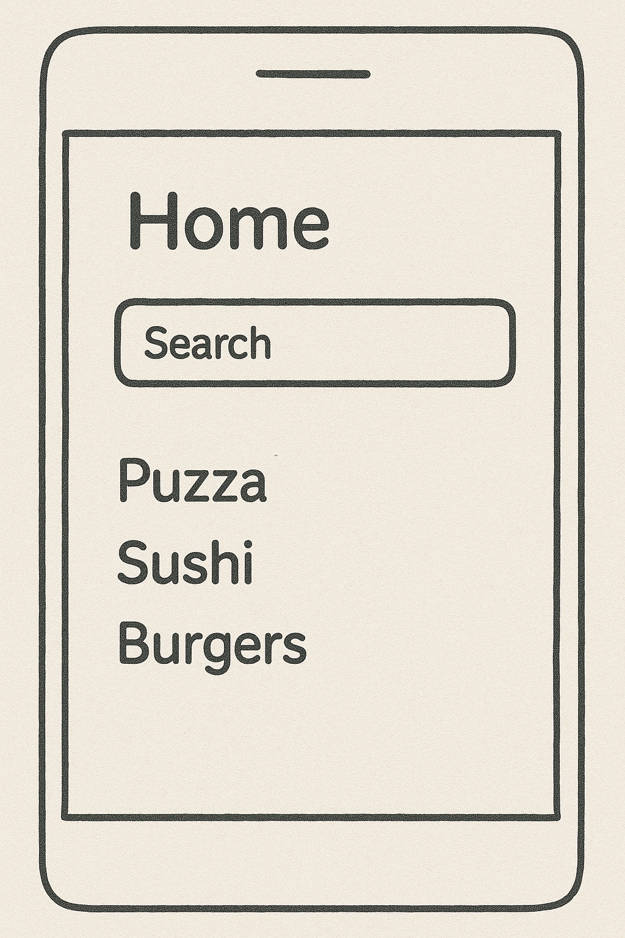

Wireframe 2: Menu Screen
Purpose: Display food items from a selected restaurant.
Steps:
- Title the screen: Menu.
- Create a list layout:
  - A square box for each item (image placeholder).
  - Next to it, write “Food Item”, a sample price ($0.00).
  - Add a button labeled "Add to Cart" for each item.
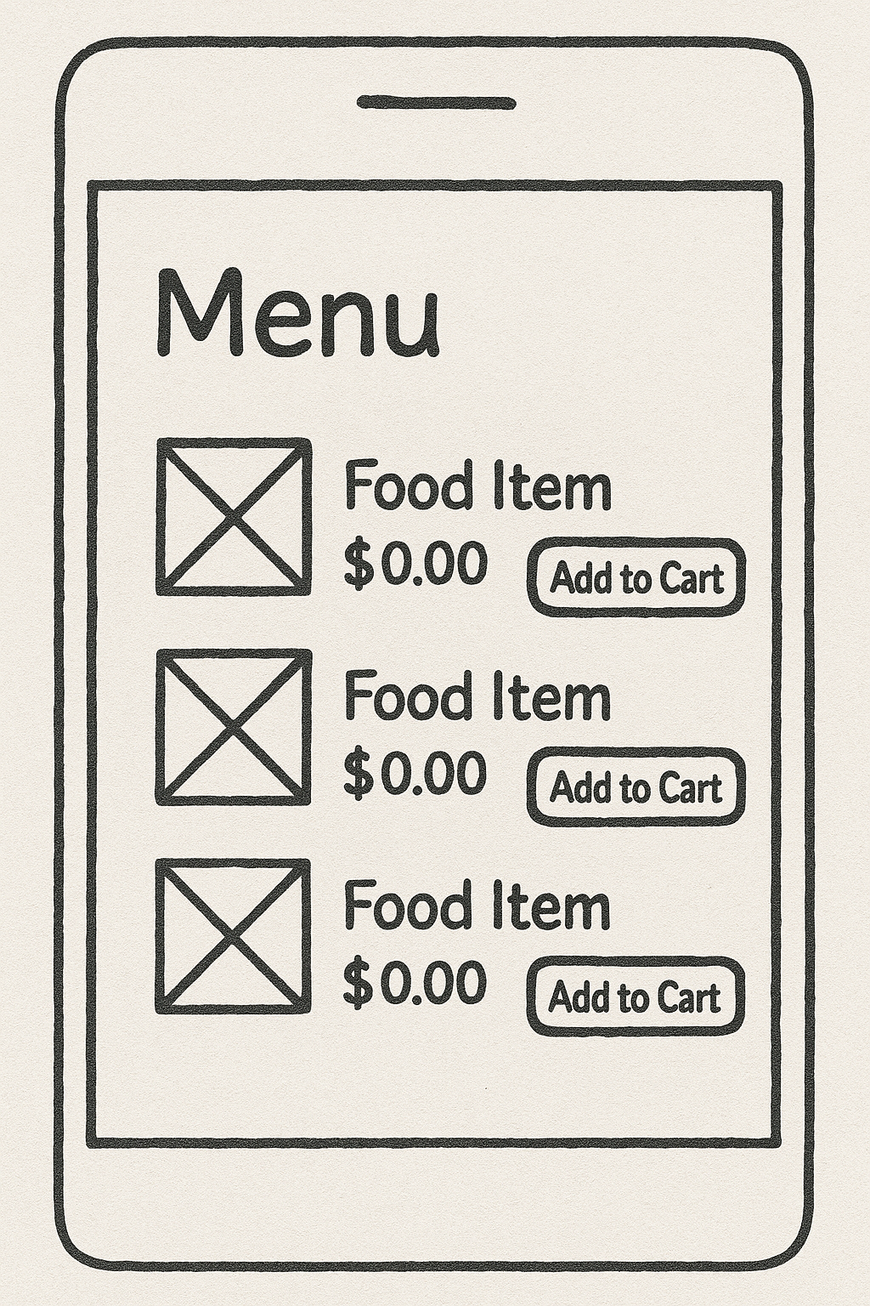
Include 2-3 sample items for consistency.

Wireframe 3: Cart Screen
Purpose: Show added items and total before checkout.
Steps:
- Title the screen: Cart.
- List 2 items (same format as menu):
  - Image placeholder
  - Item name, quantity (e.g., 1×), price
  - Optional: "Remove" or "Edit" button
- Show Total: $0.00
- Add a large "Checkout" button below.
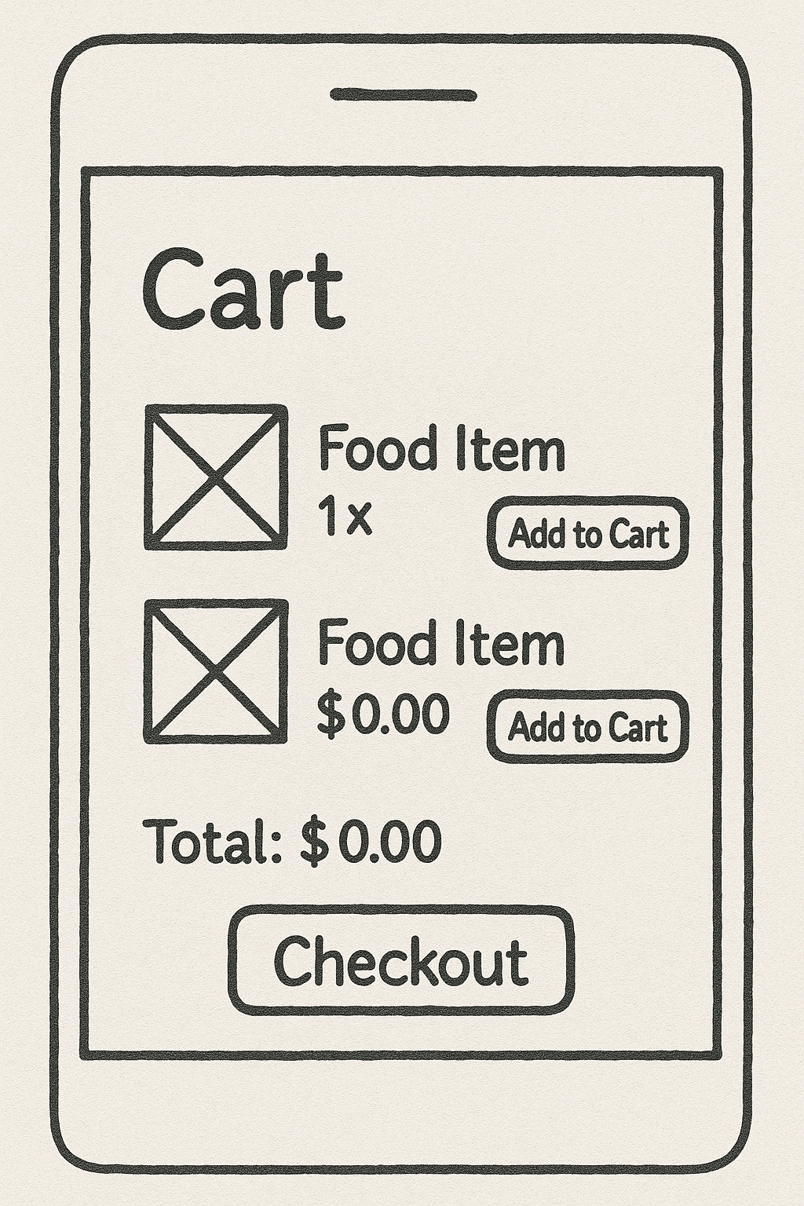
Wireframe 4: Checkout Screen
Purpose: Collect delivery address and payment details.
Steps:
- Title: Checkout
- Draw a rectangular input box labeled “Delivery Address”
- Below, add a Payment section with:
  - Radio buttons for UPI and Cash on Delivery
- At the bottom, a large "Place Order" button.
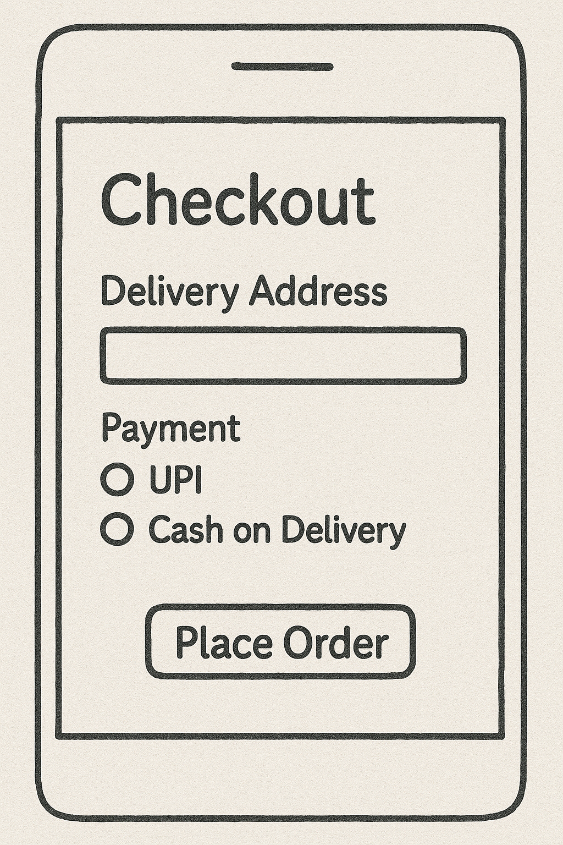

Wireframe 5: Order Confirmation Screen
Purpose: Confirm successful order and show ETA.
Steps:
- Title: Order Confirmation
- Add a centered message box saying “Order Confirmed”
- Below, include:
  - List of items ordered (e.g., 1× Margherita)
  - Payment method summary
  - Estimated Delivery Time: e.g., 30 min
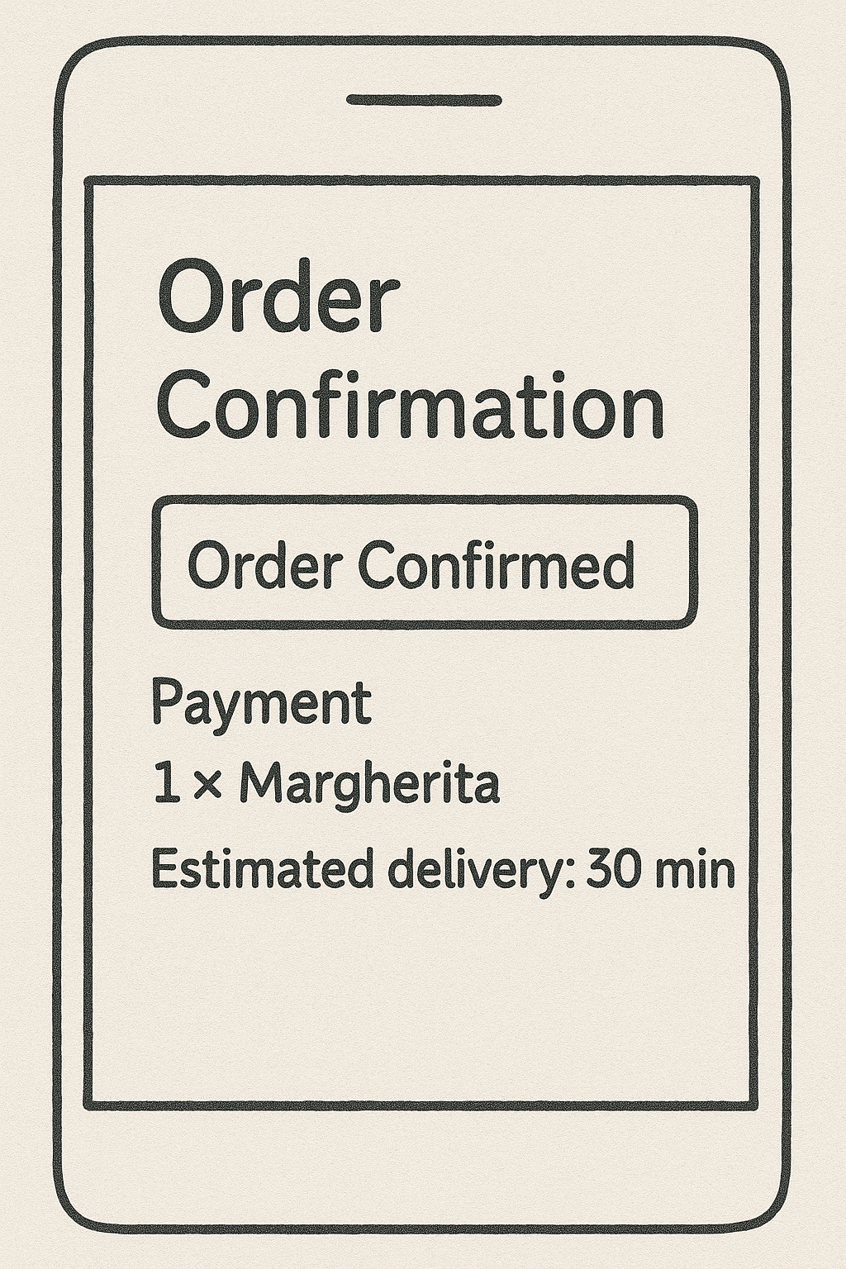
Step 3: Connect Screens as a Storyboard
- Arrange Screens horizontally or vertically.
- Use Arrows (from “Markup” tools in Balsamiq) to show the flow:
  - Home → Menu → Cart → Checkout → Confirmation

Finally we have built a user-centric storyboard that simulates the real navigation experience in a food delivery mobile app. This helps in UI/UX planning, prototyping, and user testing before actual development begins

